WATCH TV EVERYWHERE
Available to all active Glandorf Telephone Company, Inc. Video subscribers.
Log on to wtve.net This screen will appear:
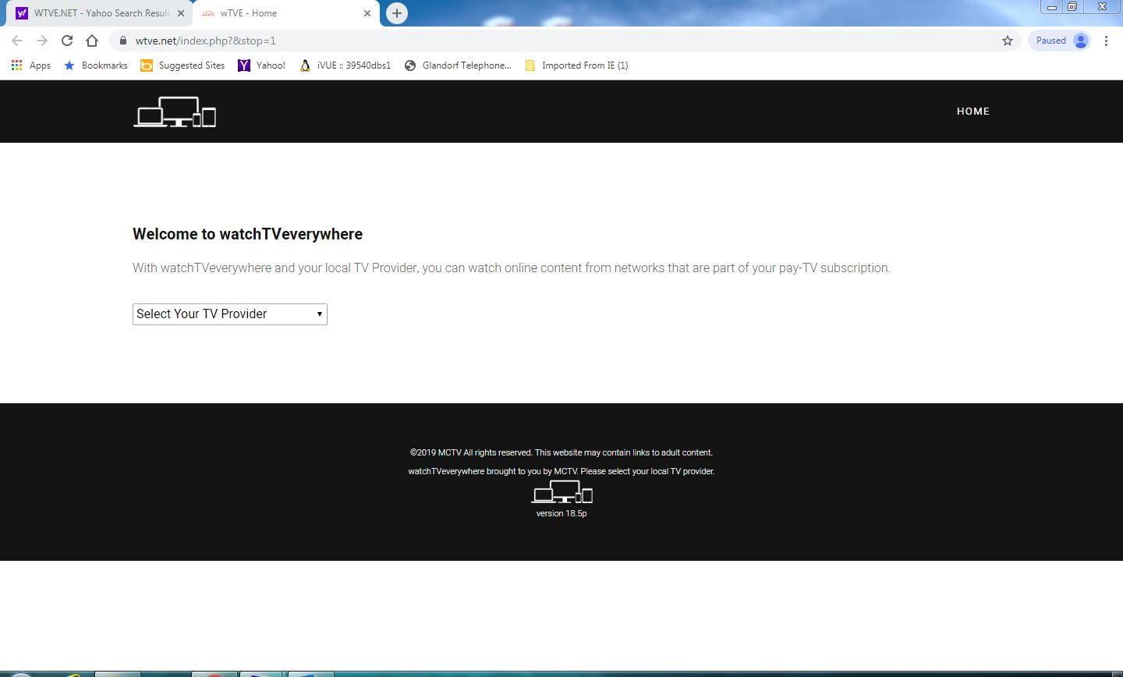

Choose Glandorf Telephone Company, Inc.
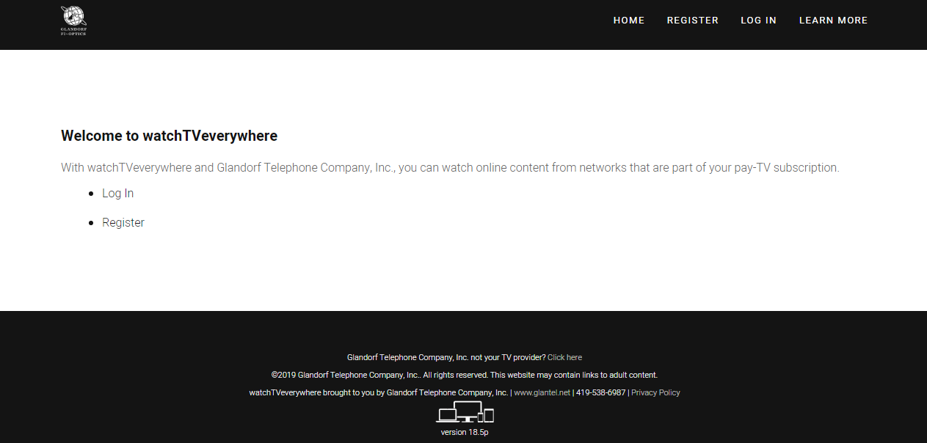
Click Register for the first time. You will need your current account number from your Glandorf Telephone Company, Inc. Bill. You will put in a valid email address and create a password.

More channels will be added as they become available.

